EX NO 7 : Identification of Assignment Operators Using LEX

Aim:
To write a LEX program to identify and print assignment operators (=, +=, -=, *=, /=) used in a given C program.
Algorithm:
- Start the program.
- Define patterns for all five assignment operators in LEX.
- Read the given C program as input.
- Identify and print each assignment operator found.
- Stop the program.

Program:

%{
#include <stdio.h>
%}

%%
"+=" { printf("Assignment Operator: +=\n"); }
"-=" { printf("Assignment Operator: -=\n"); }
"*=" { printf("Assignment Operator: *=\n"); }
"/=" { printf("Assignment Operator: /=\n"); }
"=" { printf("Assignment Operator: =\n"); }
.|\n ;
%%

int main()
{
printf("Enter the C program:\n");
yylex();
return 0;
}

int yywrap()
{
return 1;
}
Sample input:
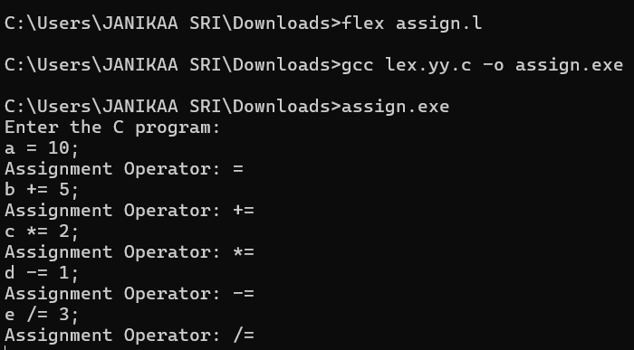

Sample output:

Result:
The LEX program was executed successfully and identified and printed all five assignment operators: =, +=, -=, *=, and /=.

